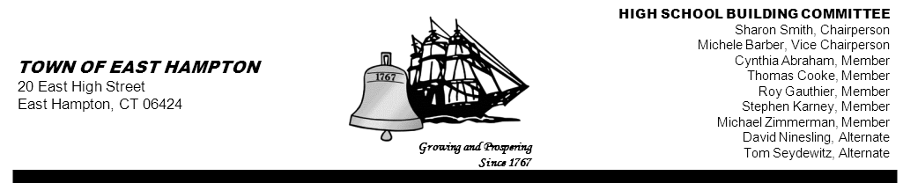

HIGH SCHOOL—ADDITION & RENOVATE-AS-NEW
BUILDING COMMITTEE MEETING
High School (Library)
15 North Maple Street, East Hampton, CT 06424
AGENDA
Thursday, May 2, 2013, 5:30 p.m.

- Call to Order

- Public Remarks

- Review and Approve Minutes from April 25,2013

- Action Items:
- Approval of Invoices

- Reports and Discussion:
- Referendum Update
- Communication Update
- Schedule Update
- Project Management Update

- Chairperson’s Report

- Public Remarks

- Adjournment

